Learning outcome- able to implement Logistic Regression and Flask app
After achieving this learning outcome, a student will be able to implement Logistic Regression and Flask app. In order to achieve this learning outcome, a student has to complete the following:

Activities:
- Implementing logistic regression for binary and multi-class classification (5 hours)
- Sigmoid function in Logistic regressions (5 hours)
- Predicting probability of classification models (3 hours)
- Charting confusion matrix (3 hours)
- Integration of analytics with django/Flask app (10 hours)

Activity 1
Aim: Implementing logistic regression for binary and multi-class classification
Learning outcome: Able to implement logistic regression for binary and multi-class classification.
Duration: 5 hours

List of Hardware/Software requirements:
- Anaconda
- Windows/Linux

Program 1:
**Import Packages, Functions, and Classes**
import matplotlib.pyplot as plt
import numpy as np
from sklearn.linear_model import LogisticRegression
from sklearn.metrics import classification_report

**Get Data**
x = np.arange(10).reshape(-1, 1)
y = np.array([0, 0, 0, 0, 1, 1, 1, 1, 1, 1])
x
y
**Create a Model and Train**
model = LogisticRegression(solver='liblinear', random_state=0)
model.fit(x, y)
**Classification model defined**
model.classes_
**Evaluate the Model**
model.predict_proba(x)
model.predict(x)
model.score(x, y)

Output/Results snippet:

Program 2:
**Import Packages, Functions, and Classes**
import matplotlib.pyplot as plt
import seaborn as sns
from sklearn.linear_model import LogisticRegression
from sklearn.metrics import classification_report
from sklearn.metrics import accuracy_score
from sklearn.model_selection import train_test_split

**Load the Data set**
data = sns.load_dataset("iris")
data.head()
**Prepare the training set**
# x = feature values, all the columns except the last column
x = data.iloc[:, :-1]
# y = target values, last column of the data frame
y = data.iloc[:, -1]
**Split the data into 80% training and 20% testing**
x_train, x_test, y_train, y_test = train_test_split(x, y, test_size=0.2, random_state=42)
**Train the model**
model = LogisticRegression()
model.fit(x_train, y_train)
**Evaluate the model**
predictions = model.predict(x_test)
print(predictions)# printing predictions
print () # Printing new line
print (classification_report(y_test, predictions) )
print (accuracy_score(y_test, predictions))

Output/Results snippet:
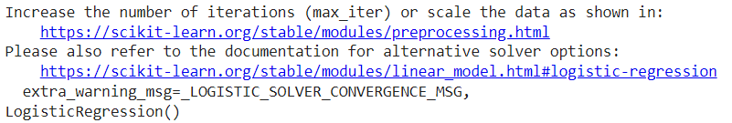
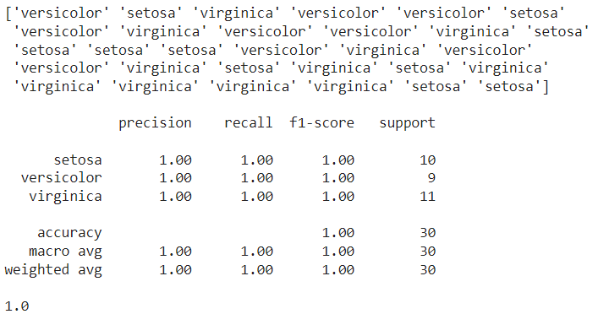

References:
    - https://www.w3schools.com/https://www.datacamp.com/community/tutorials/understanding-logistic-regression-python
    - https://realpython.com/logistic-regression-python/
    - https://randerson112358.medium.com/python-logistic-regression-program-5e1b32f964db

Activity 2
Aim: Implementing sigmoid function in logistic regression
Learning outcome: Able to implement sigmoid function in logistic regression.
Duration: 5 hours

List of Hardware/Software requirements:
- Anaconda
- Windows/Linux

Program:
**Import Packages, Functions, and Classes**
import matplotlib.pyplot as plt
import seaborn as sns
from sklearn.linear_model import LogisticRegression
from sklearn.metrics import classification_report
from sklearn.metrics import accuracy_score
from sklearn.model_selection import train_test_split
from scipy import optimize as op

**Load the Data set**
data_iris = sns.load_dataset("iris")
data_iris.head()
**Data setup**
import numpy as np
species = ['setosa', 'versicolor', 'virginica']
# Number of examples
m = data_iris.shape[0]
# Features
n = 4
# Number of classes
k = 3
X = np.ones((m,n + 1))
y = np.array((m,1))
X[:,1] = data_iris['petal_length'].values
X[:,2] = data_iris['petal_width'].values
X[:,3] = data_iris['sepal_length'].values
X[:,4] = data_iris['sepal_width'].values

# Labels
y = data_iris['species'].values

# Mean normalization
for j in range(n):
X[:, j] = (X[:, j] - X[:,j].mean())
**Split the data into 80% training and 20% testing**
x_train, x_test, y_train, y_test = train_test_split(x, y, test_size=0.2, random_state=11)
x = data_iris.drop(['species'], axis=1)
y = data_iris['species']
**Define functions**
# Sigmoid function
def sigmoid(z):
return 1.0 / (1 + np.exp(-z))

# Regularized cost function
def reglrCostFunction(theta, X, y, lambda_s = 0.1):
m = len(y)
h = sigmoid(X.dot(theta))
J = (1 / m) * (-y.T.dot(np.log(h)) - (1 - y).T.dot(np.log(1 - h)))
reg = (lambda_s/(2 * m)) * np.sum(theta**2)
J = J + reg
return J

# Regularized gradient function
def reglrGradient(theta, X, y, lambda_s = 0.1):
m, n = X.shape
theta = theta.reshape((n, 1))
y = y.reshape((m, 1))
h = sigmoid(X.dot(theta))
reg = lambda_s * theta /m
gd = ((1 / m) * X.T.dot(h - y))
gd = gd + reg
return gd

def logisticRegression(X, y, theta):
result = op.minimize(fun = reglrCostFunction, x0 = theta, args = (X, y),
method = 'TNC', jac = reglrGradient)
return result.x
**Training the model**
all_theta = np.zeros((k, n + 1))
# One vs all
i = 0
for flower in species:
tmp_y = np.array(y_train == flower, dtype = int)
optTheta = logisticRegression(X_train, tmp_y, np.zeros((n + 1,1)))
all_theta[i] = optTheta
i += 1
**Evaluate the model**

Prob = sigmoid(X_test.dot(all_theta.T)) # probability for each flower

pred = [species[np.argmax(Prob[i, :])]

for i in range(X_test.shape[0])]

print(" Test Accuracy ", accuracy_score(y_test, pred) * 100 , '%')

Output/Results snippet:
References:
    - https://www.pluralsight.com/guides/designing-a-machine-learning-model
    - https://realpython.com/logistic-regression-python/
    - https://randerson112358.medium.com/python-logistic-regression-program-5e1b32f964db

Activity 3
Aim: Write a code for predicting probability of classification models
Learning outcome: Able to implement predicting probability of classification models.
Duration: 3 hours
List of Hardware/Software requirements:
- Anaconda
- Windows/Linux

Program:

from sklearn.datasets import load_breast_cancer

from sklearn.linear_model import LogisticRegression

from sklearn.model_selection import train_test_split

from sklearn import metrics

import pandas as pd

import numpy as np

from matplotlib import pyplot as plt

import seaborn as sns

sns.set_style('darkgrid')

# Choose a binary classification problem

data = load_breast_cancer()

# Develop predictors X and target y dataframes

X = pd.DataFrame(data['data'], columns=data['feature_names'])

y = abs(pd.Series(data['target'])-1)

# Split data into train and test set in 80:20 ratio

X_train, X_test, y_train, y_test = train_test_split(X,y,test_size=0.2, random_state=1)

# Build a RF model with default parameters

model = LogisticRegression(random_state=1)

model.fit(X_train, y_train)

preds = model.predict(X_test)

accuracy = metrics.accuracy_score(y_test, preds)

accuracy

Output/Results snippet:
References:
    - https://analyticsindiamag.com/evaluation-metrics-in-ml-ai-for-classification-problems-wpython-code/
Activity 4
Aim: Write a code for charting confusion matrix
Learning outcome: Able to chart confusion matrix.
Duration: 3 hours
List of Hardware/Software requirements:
- Anaconda
- Windows/Linux

Program:

from sklearn.datasets import load_breast_cancer

from sklearn.linear_model import LogisticRegression

from sklearn.model_selection import train_test_split

from sklearn import metrics

import pandas as pd

import numpy as np

from matplotlib import pyplot as plt

import seaborn as sns

sns.set_style('darkgrid')

# Choose a binary classification problem

data = load_breast_cancer()

# Develop predictors X and target y dataframes

X = pd.DataFrame(data['data'], columns=data['feature_names'])

y = abs(pd.Series(data['target'])-1)

# Split data into train and test set in 80:20 ratio

X_train, X_test, y_train, y_test = train_test_split(X,y,test_size=0.2, random_state=1)

# Build a RF model with default parameters

model = LogisticRegression(random_state=1)

model.fit(X_train, y_train)

preds = model.predict(X_test)

accuracy = metrics.accuracy_score(y_test, preds)

accuracy

metrics.plot_confusion_matrix(model, X_test, y_test, display_labels=['Negative', 'Positive'])

precision_positive = metrics.precision_score(y_test, preds, pos_label=1)

precision_negative = metrics.precision_score(y_test, preds, pos_label=0)

precision_positive, precision_negative

recall_sensitivity = metrics.recall_score(y_test, preds, pos_label=1)

recall_specificity = metrics.recall_score(y_test, preds, pos_label=0)

recall_sensitivity, recall_specificity

f1_positive = metrics.f1_score(y_test, preds, pos_label=1)

f1_negative = metrics.f1_score(y_test, preds, pos_label=0)

f1_positive, f1_negative

Output/Results snippet:
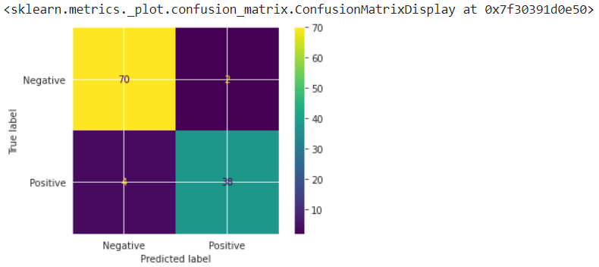
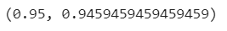

References:
    - https://analyticsindiamag.com/evaluation-metrics-in-ml-ai-for-classification-problems-wpython-code/

Activity 5
Aim: Write a code for integration of analytics with Flask app
Learning outcome: Able to integration of analytics with Flask app.
Duration: 10 hours
List of Hardware/Software requirements:
- Anaconda
- Windows/Linux

Program:

Classification Model (model.py)

import pandas as pd

import numpy as np

import seaborn as sns

from sklearn.linear_model import LogisticRegression

data = sns.load_dataset("iris")

data.head()

variety_mappings = {0: 'Setosa', 1: 'Versicolor', 2: 'Virginica'}

data = data.replace(['Setosa', 'Versicolor' , 'Virginica'],[0, 1, 2])

X = data.iloc[:, 0:-1]

y = data.iloc[:, -1]

logreg = LogisticRegression()

logreg.fit(X, y)

def classify(a, b, c, d):

arr = np.array([a, b, c, d])

arr = arr.astype(np.float64)

query = arr.reshape(1, -1)

prediction = variety_mappings[logreg.predict(query)[0]]

return prediction

HTML webpage (home.html)

<!DOCTYPE html>

<html>

<head>

<meta charset="utf-8">

<meta name="viewport" content="width=device-width, initial-scale=1.0">

<title>Flower Variety</title>

<link rel="stylesheet"

href="https://cdnjs.cloudflare.com/ajax/libs/bulma/0.9.0/css/bulma.min.css">

<link href="https://fonts.googleapis.com/icon?family=Material+Icons"

rel="stylesheet">

<style>

html{

overflow: hidden;

}

body{

position: absolute;

width: 100%;

height: 100%;

margin: 0;

padding: 0;

}

#login-form-container{

position: absolute;

width: 100%;

height: 100%;

display: flex;

align-items: center;

justify-content: center;

}

</style>

</head>

<body>

<div id="login-form-container">

<form action="classify" method="GET">

<div class="card" style="width: 400px">

<div class="card-content">

<div class="media">

<div class="is-size-4 has-text-centered">Flower Variety Classification</div>

</div>

<div class="content">

<div class="field">

<p class="control">

Sepal Length: <input class="input" type="number" value='0.00' step='0.01' name="slen" id="slen">

</p>

</div>

<div class="field">

<p class="control">

Sepal Width: <input class="input" type="number" value='0.00' step='0.01' name="swid" id="swid">

</p>

</div>

<div class="field">

<p class="control">

Petal Length: <input class="input" type="number" value='0.00' step='0.01' name="plen" id="plen">

</p>

</div>

<div class="field">

<p class="control">

Petal Width: <input class="input" type="number" value='0.00' step='0.01' name="pwid" id="pwid">

</p>

</div>

<div class="field">

<button class="button is-fullwidth is-rounded is-success">Submit</button>

</div>

</div>

</div>

</form>

</div>

</body>

</html>

output.html

<!DOCTYPE html>

<html>

<head>

<meta charset="utf-8">

<meta name="viewport" content="width=device-width, initial-scale=1.0">

<title>Flower Variety</title>

<link rel="stylesheet"

href="https://cdnjs.cloudflare.com/ajax/libs/bulma/0.9.0/css/bulma.min.css">

<link href="https://fonts.googleapis.com/icon?family=Material+Icons" rel="stylesheet">

<style>

html{

overflow: hidden;

}

body{

position: absolute;

width: 100%;

height: 100%;

margin: 0;

padding: 0;

}

#login-form-container{

position: absolute;

width: 100%;

height: 100%;

display: flex;

align-items: center;

justify-content: center;

}

</style>

</head>

<body>

<div id="login-form-container">

<div class="card" style="width: 400px">

<div class="card-content">

<div class="media">

<div class="is-size-4 has-text-centered">{{ variety }}</div>

</div>

<form action="home">

<div class="field">

<button class="button is-fullwidth is-rounded is-success">Retry</button>

</div>

</form>

</div>

</div>

</div>

</body>

</html>

Flask Framework (server.py)

import model

from flask import Flask, request, render_template,jsonify

app = Flask(__name__,template_folder="templates")

# Default route set as 'home'

@app.route('/home')

def home():

return render_template('home.html') # Render home.html

# Route 'classify' accepts GET request

@app.route('/classify',methods=['POST','GET'])

def classify_type():

try:

sepal_len = request.args.get('slen')

sepal_wid = request.args.get('swid')

petal_len = request.args.get('plen')

petal_wid = request.args.get('pwid')

variety = model.classify(sepal_len, sepal_wid, petal_len, petal_wid)

return render_template('output.html', variety=variety)

except:

return 'Error'

if(__name__=='__main__'):

app.run(debug=True)

Output/Results snippet:
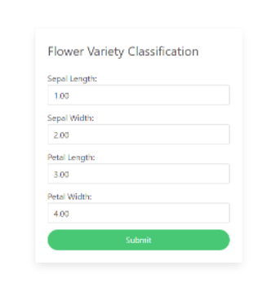


References:
    - https://www.section.io/engineering-education/deploying-machine-learning-models-using-flask/

